

|  |  |
| --- | --- |
| **Nombre:** Tipanguano Santamaria Samantha Nicole | **Career:** Tecnologías de la Información |
| **Subject:** Fundamentals of Web Systems | **NRC:** 4628 |
| **Theme:** Human Interaction- 4 Laws | **Date:** 23-06-2021 |

**Human Interface – 4 Laws**

**1.- A computer shall not harm your work or, through inaction, allow your work to come to harm**.

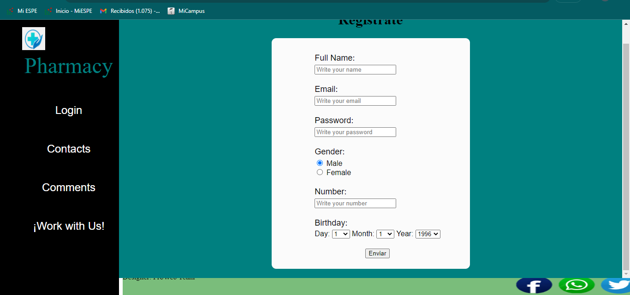

In this rule, I believe that my web page does not comply with rule 1, since the form for the registration of a new user, if a box is not filled in, everything is deleted and it is filled out again and in any case shouldn't pass edo, it should show an error box, telling the user that they need to fill in a field.

**2.- A computer shall not waste your time or require you to do more work tan is strictly necessary.**

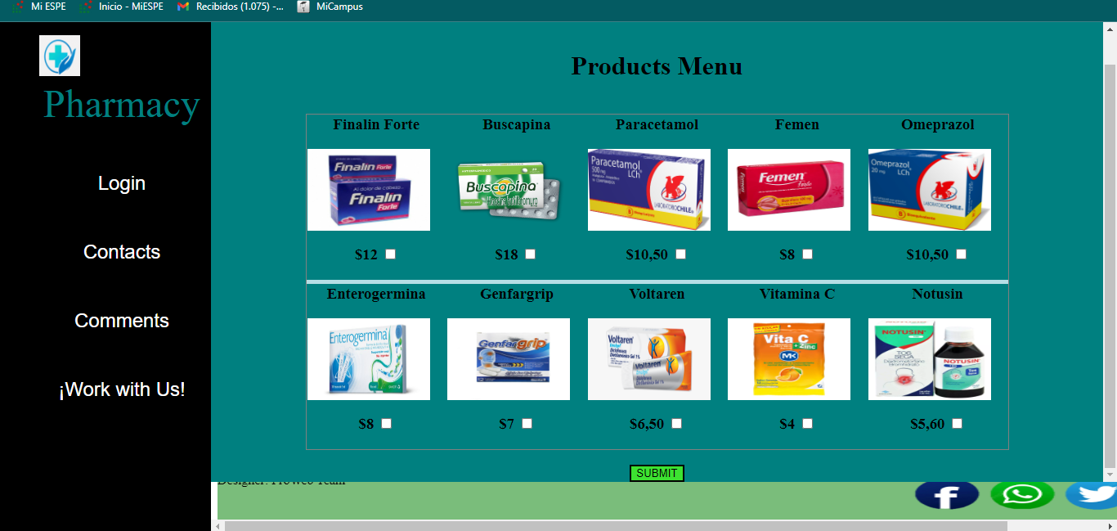

In this rule, I believe that my web page does not fit rule 2, since my web page is not intuitive with the user, in this way the user would enter or search for data manually, which instead, be the computer who by intuition fills in or complies with these data.

**3.- An interface is humane if it is responsive to human needs and considérate of human frailties.**



In this rule, I believe that my web page does not fit rule 3, since it is not receptive to human needs, so it does not have that effect of the user's attention center that in its entirety would be the screen and not your keyboard, which is why my website is not user sensitive.

**4.- The user should set the pace of interaction.**



In this rule, I believe that my web page does not conform to rule 4, since we have not controlled the way in which the user-computer interaction communicates, in this case the system could improve preferences by automatically adapting its rhythm to converge towards that of the user and thus facilitate and coordinate the interaction between them.